**DAY 3 CLASS EXERCISES**

**CLASS EXERCISE - 1**

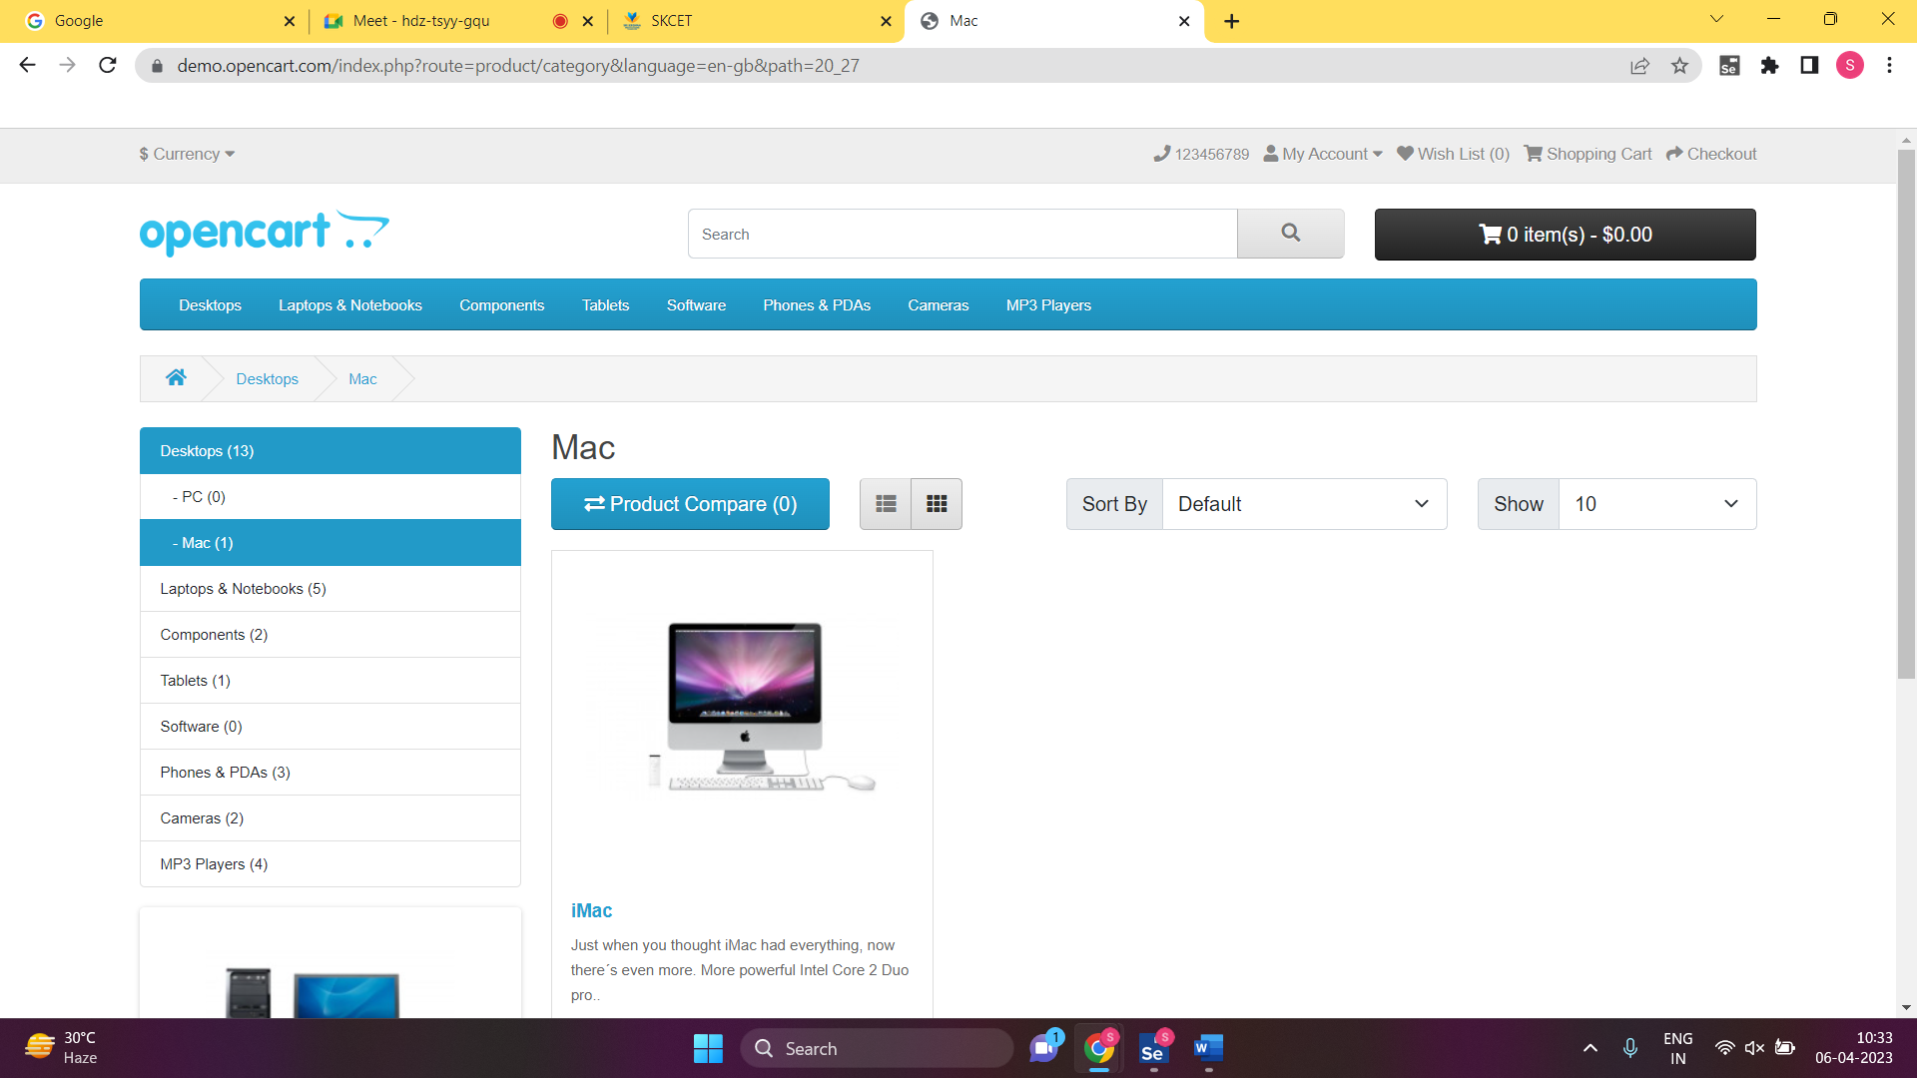

**CLASS EXERCISE – 2**

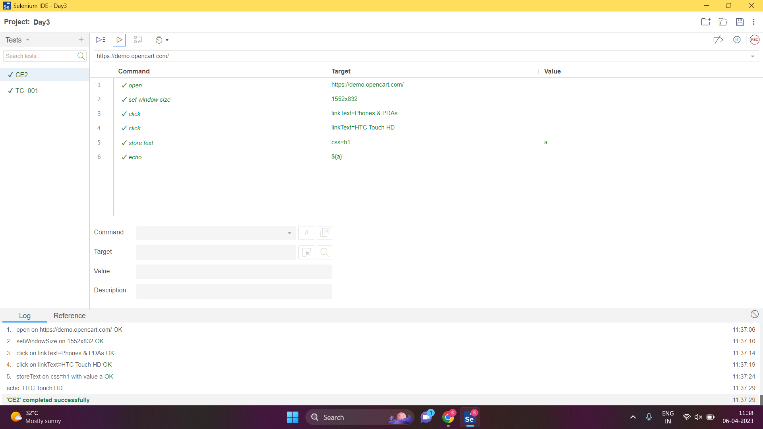

**CLASS EXERCISE – 3**

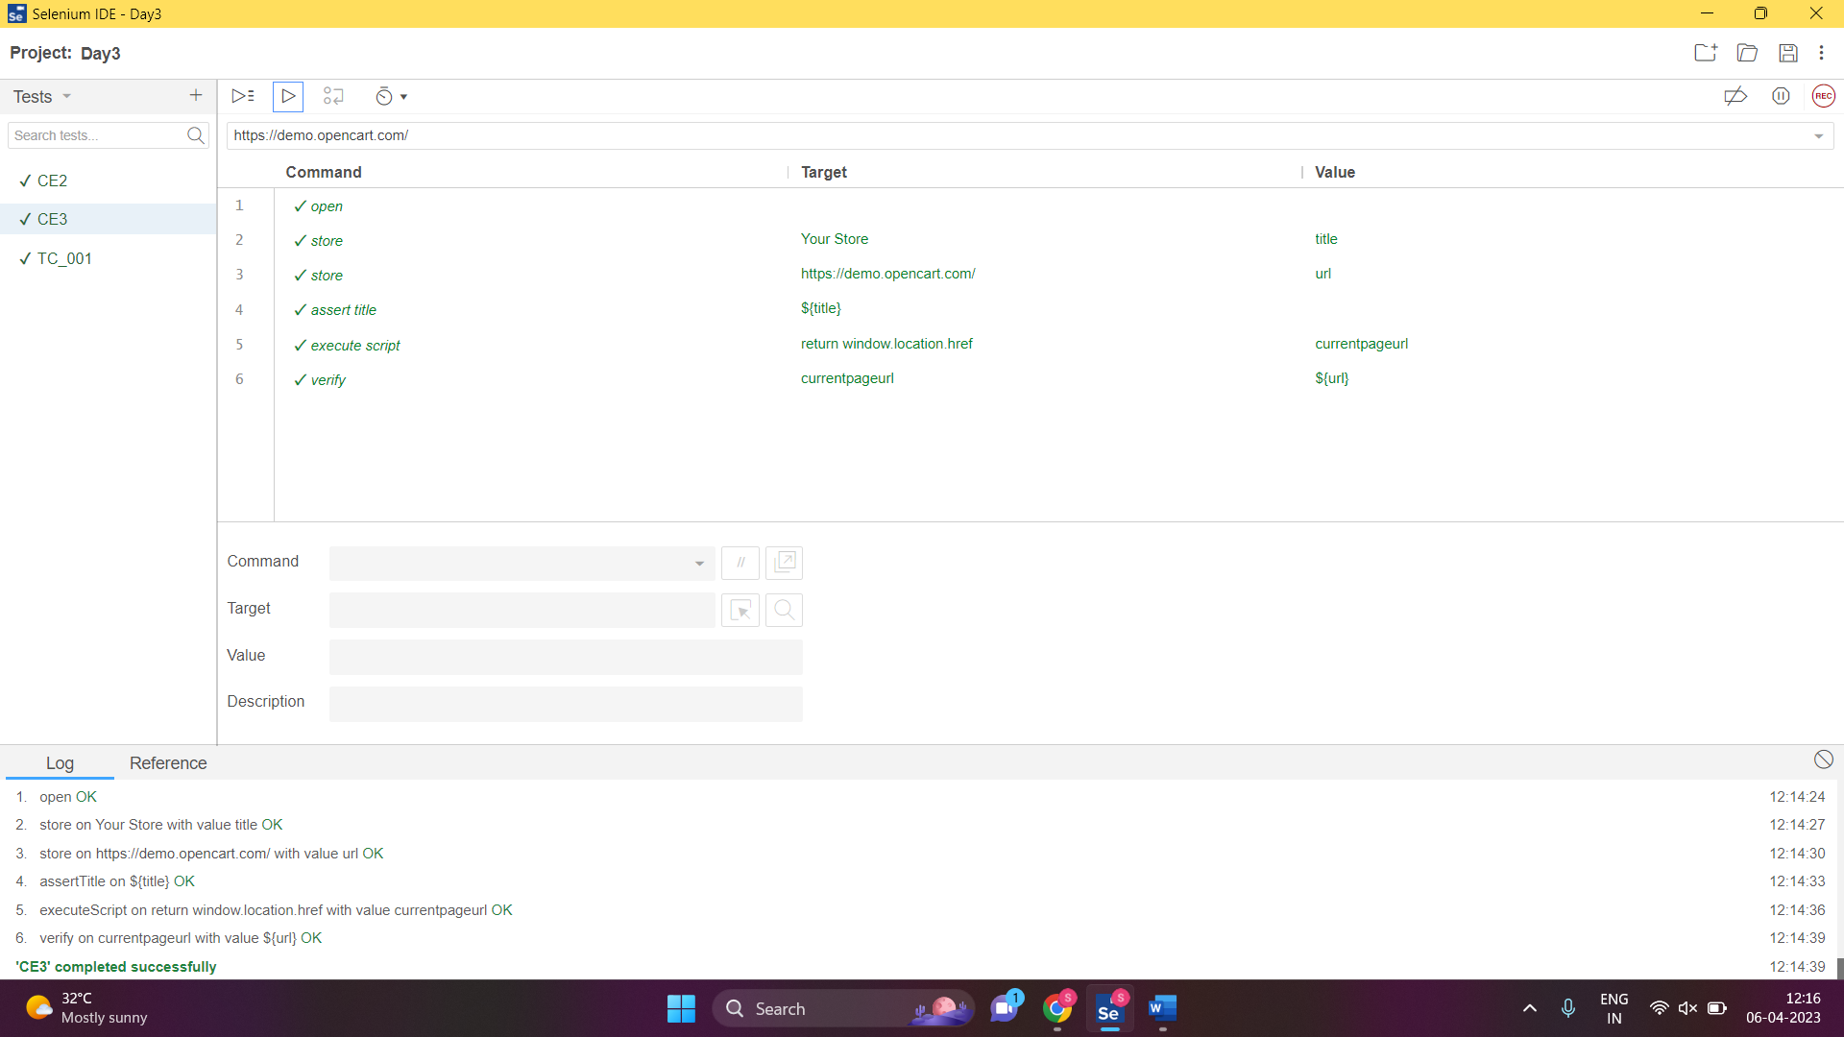

**CLASS EXERCISE – 4**

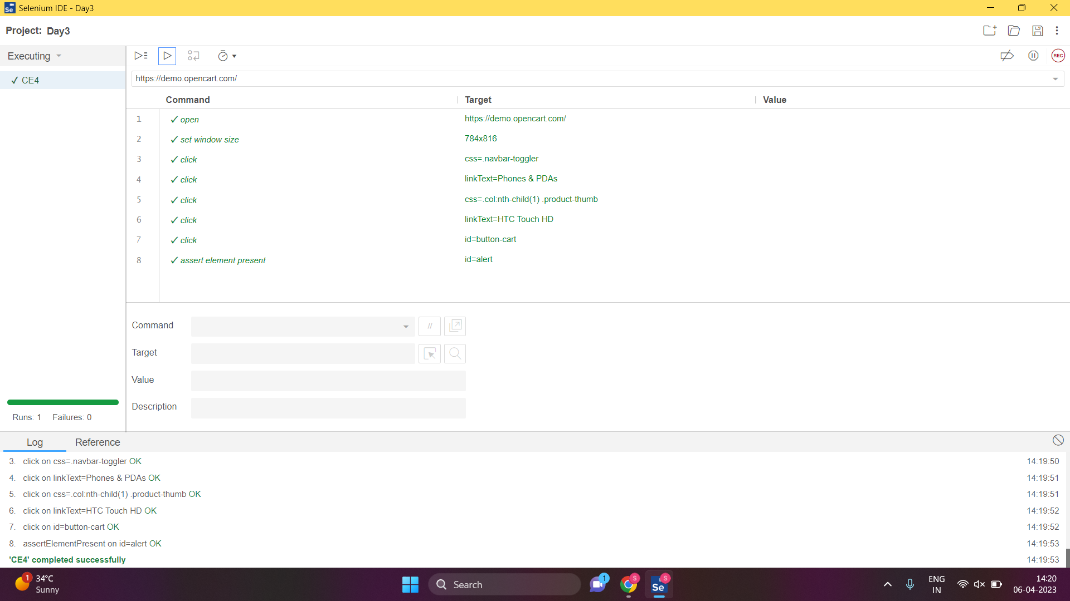

**CLASS EXERCISE – 5**

